How to run the app

1. Extract the folder and open it.
2. Copy the path after opening the folder.
3. Now open CMD in windows or terminal in linux.
   1. Change your directory using below command.

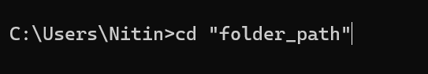

* 1. Now activate the environment already in the folder.
  2. Use below command to activate the environment
  3. 
  4. After executing above command some text will come in starting of cmd.

Like

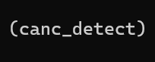

1. Now install the requirements (use below command to install)
2. 
3. After executing above command all package will install.
4. After that run below command to run the app.



OR



1. After executing above web address will be displaying in output copy that address and paste it into the search bar of browser.

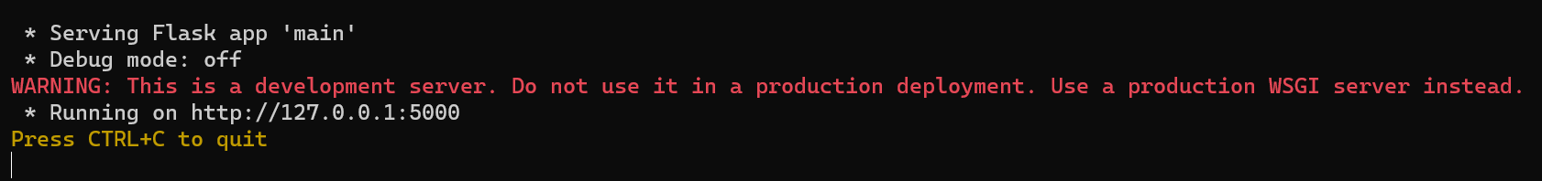

1. Open browser and paste it into the search box and enter.

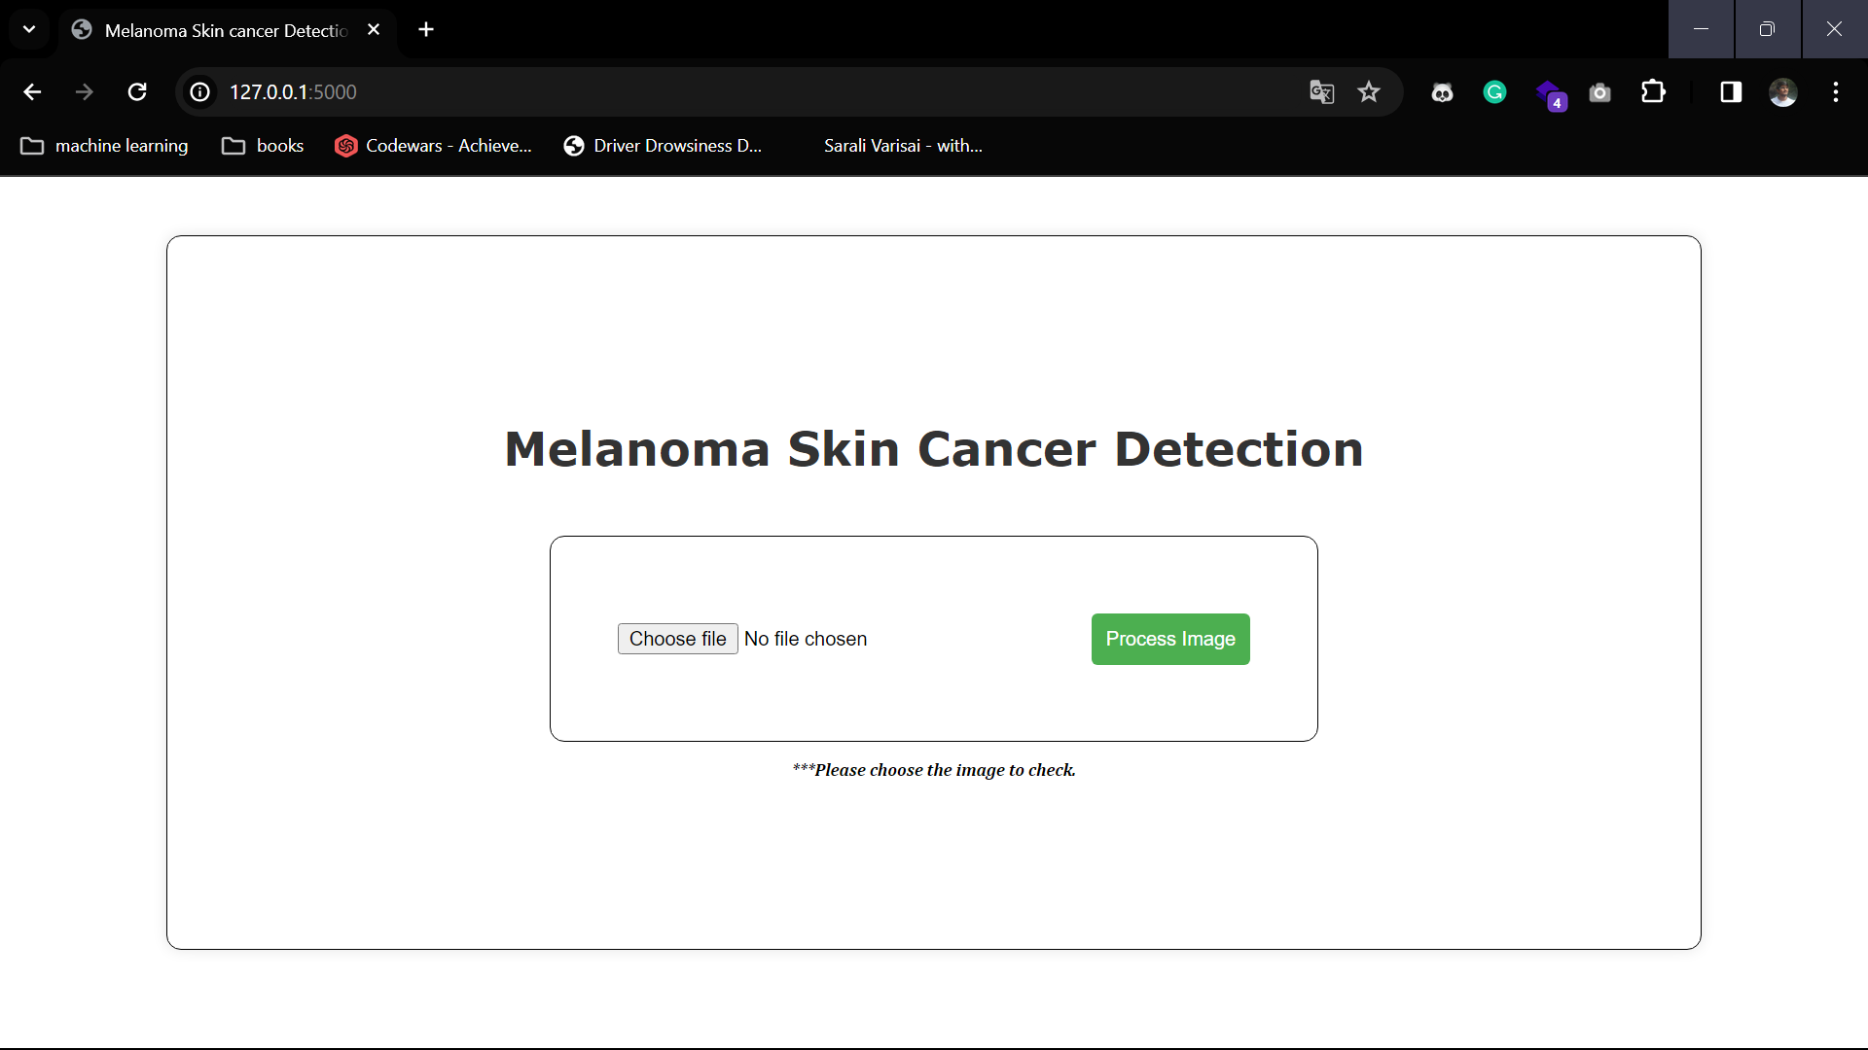

1. Above Output will be displayed.